


Copado-CLI Installation


Document Control Information
Document Information
Document Name | Copado Cli installation Document v2.0.1
Project Name | Humana Salesforce DevOps
Client | Humana
Document Author | Rama Chandra Rao Puvvula
Document Version | 1.0
Document Status | Completed
Date Released | 7/26/2023
Document Edit History
Version | Date | Additions/Modifications | Prepared/Revised by
Document Review/Approval History
Date | Name | Organization/Title | Comments

Table of Contents
1. Copado CLI Pre-requisites 5

2. Copado CLI Installation 5

Introduction

This document will helps us step by step process to install Copado-Cli 2.0.1 with guided screens for the workflow.

Copado-cli pre-requisites
First we need to request to install the following pre-requisites using go/software. Follow the to install pre-requisites.
Pre-Requisites:

- Install Node JS (As Copado Cli is a npm package)
- Install Salesforce CLI

- Install Node JS:
You can request to install Node JS from go/software > Node.js Foundation Node.js.18.12.1 > Install ticket on this computer
Use link : Humana Software Certification - Discover Software

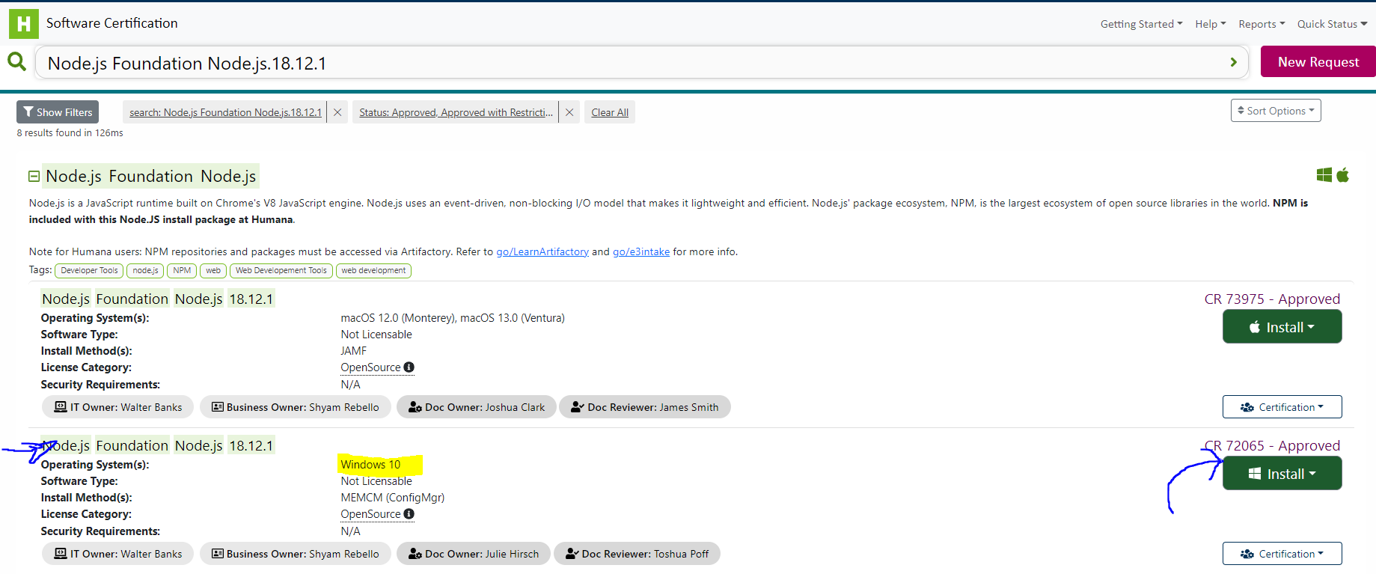

Once the installation is complete. Open cmd from start menu and try just “npm -v” command to see the version.
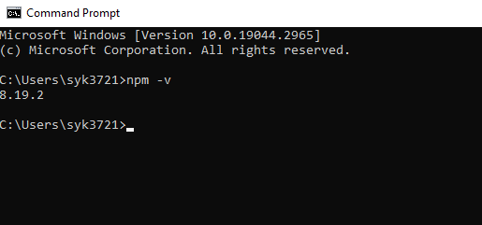

If it says “npm command not found”. Please request it one more time through go/software or reach out to CSS IT support via a generic request Request Something - Associate Support Center (service-now.com)

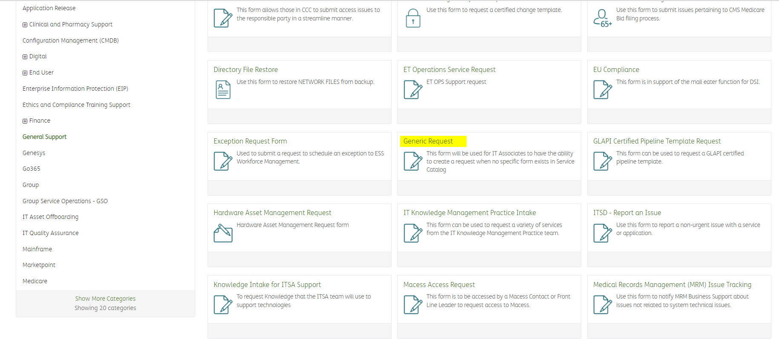

- Install Salesforce CLI:
- Once the npm gets installed and verified, we need to install salesforce CLI same way. As Copado CLI is a plugin coming from Salesforce CLI.
- Install using go/software > salesforce cli 7.74.1 > Install ticket on this computer
- Use link: Humana Software Certification - Discover Software

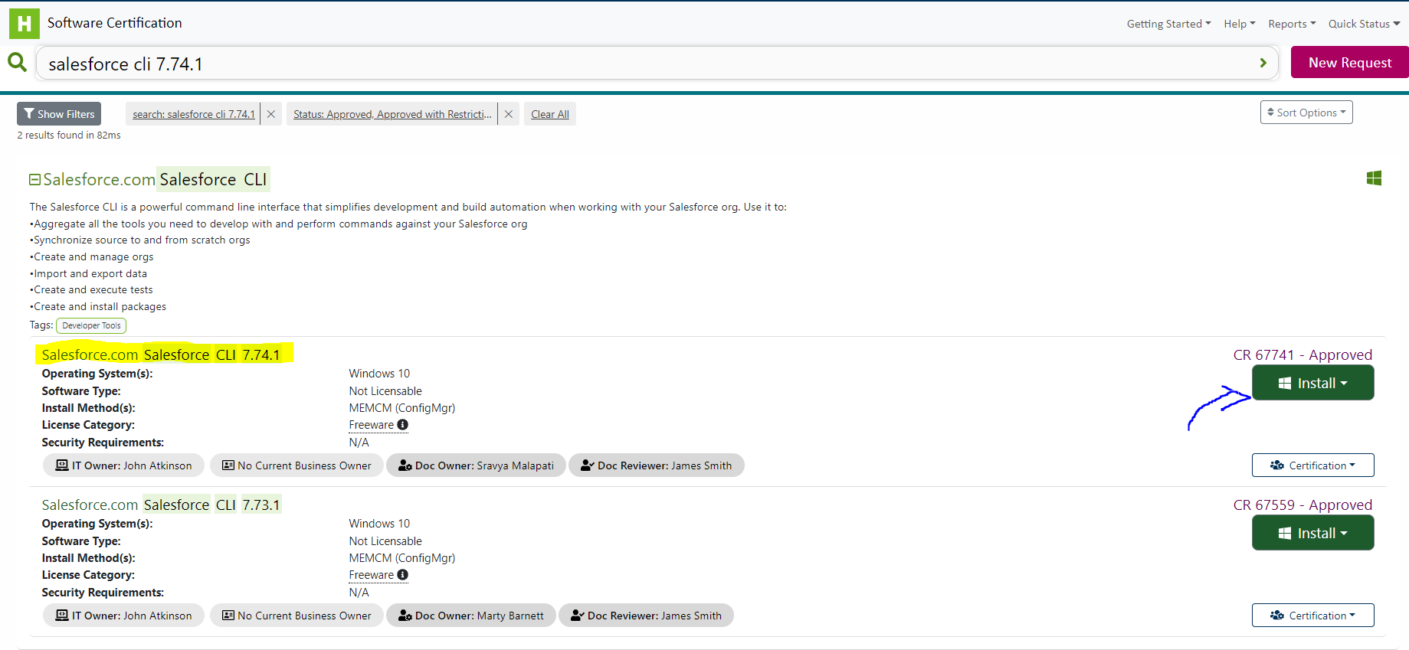

To verify open cmd from start menu and type “sfdx” to check the version installed.

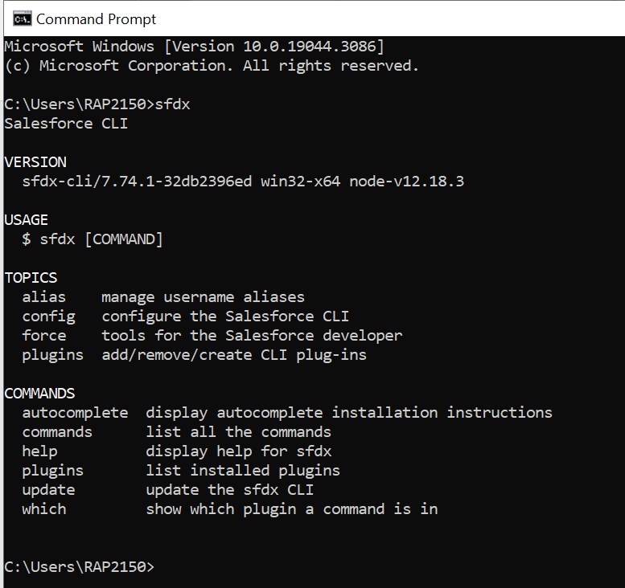

If you do not see the version like above, please open up a support ticket with CSS IT Support as mentioned above.

Copado-cli 2.0.1 Installation

Download the e3copado.zip file and place it in the user directory C:\Users\<YourUserDir>

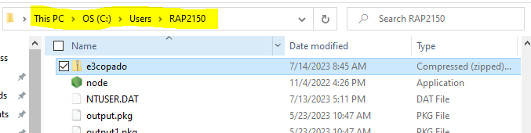

Click one3copado.zip and do “Extract all”

It should look like this

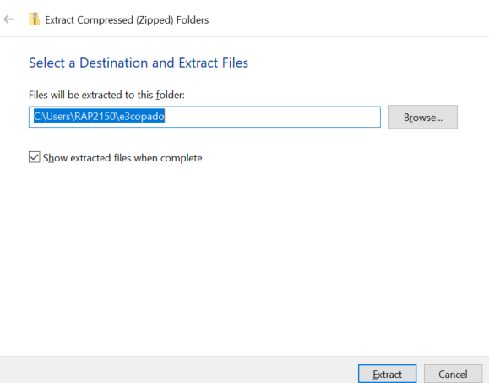

Once e3copado folder is in User directory. Run the install.bat file as Administrator.

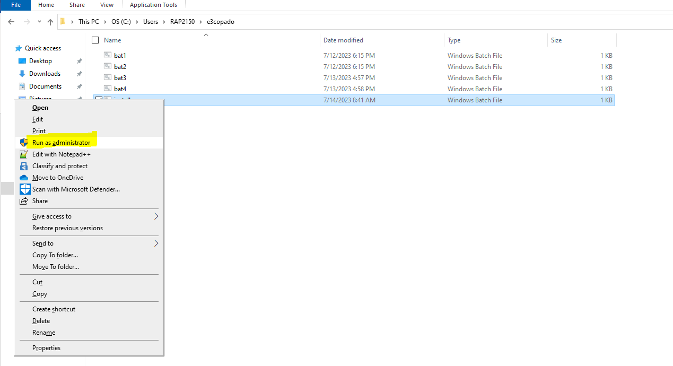

This will open 4 different cmd windows and you can minimize them and installation will take 15-20 mins depending on the internet connection.

Once the last cmd windows sfdx update is completed – copado Cli 2.0.1 installation Is successful.

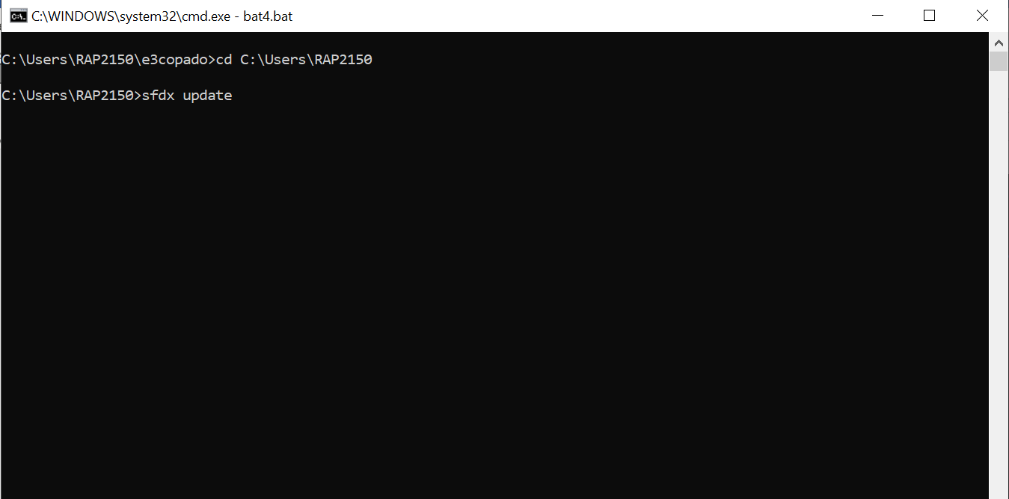

Keep checking this cmd window. Once this sfdx update window is completed – Installation is successful.

Testing:

You can test by running “sfdx copado --help” in your cmd prompt. It should give you output like below

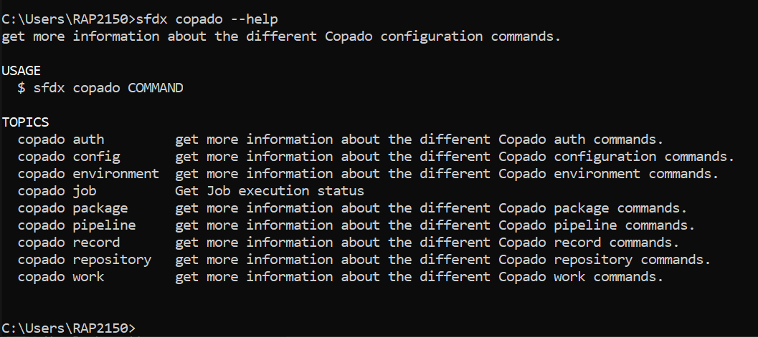

Remember sfdx Copado commands are case sensitive , we have to pass with lower case letters.

Usage:

Here is list of commands CLI Commands (copado.com)

Here is the setup instructions CLI Setup (copado.com) .

Now you can start with step 3 in the below screenshot to setup credentials from the link CLI Setup (copado.com)

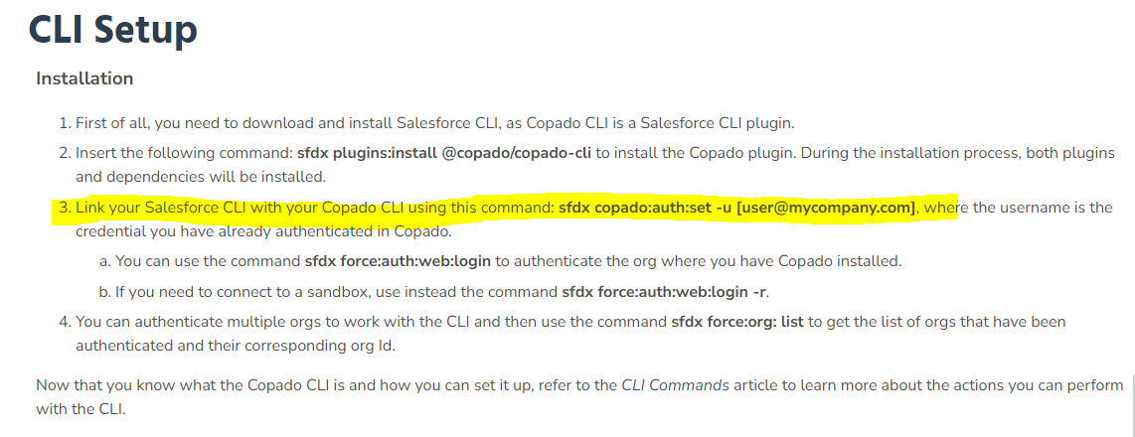

Troubleshooting Copado-cli installation :

- Make sure you have stable internet connection while running the install.bat.
- Always follow the progress of all 4 command windows that will open during the installation.
- You can open the bat files individually using notepad++ and manually run the commands in the cmd if the particular cmd window batch files fails.
- Always try to re-run the install.bat if “sfdx Copado –help” command doesn’t work.
- Most common issue we see is during “sfdx update”
- If sfdx update takes long time, close any open visual studio/VS code and run the command “sfdx update” in PowerShell or Git Bash”
- Remember sfdx update will take more time depending on the connection.

